# LEAP-210 Script Python to transfer manually using AWS CLI (Prompt)

#### Target: Create a TEXT File to move from Source to Target using AWS CLI aws s3 mv s3://agropur-global-nonprod-account-dev-sapco/SAPCO/Inbound/Financials/Costing/ s3://agropur-global-nonprod-account-dev-sapco/SAPCO/Archive/Financials/Costing/ --recursive

Step 1 – Find the repository AWS_CLI_Manual_transfert_files_GitHub at AgropurD-A profile.

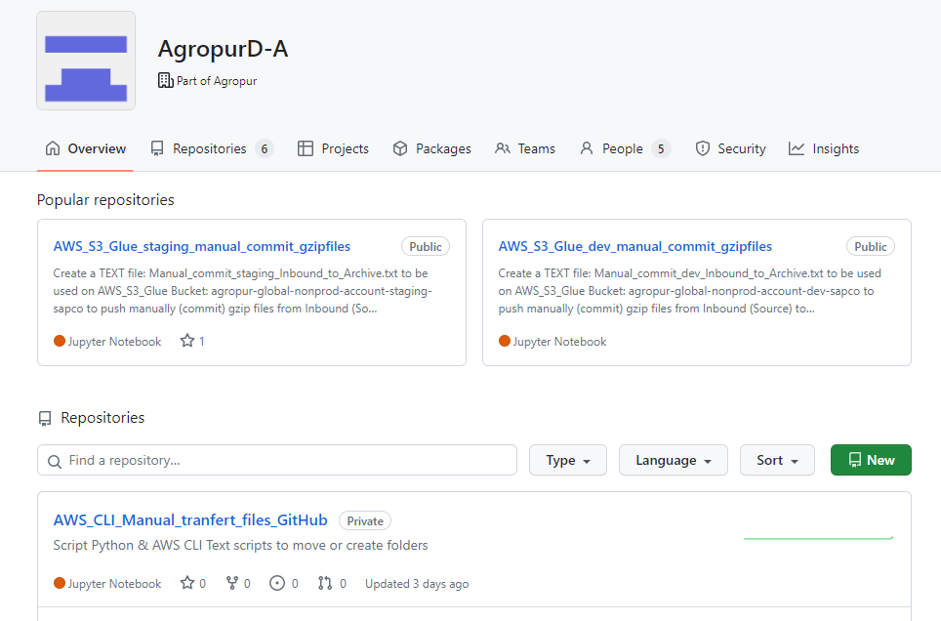

Step 2 – Select the .TXT files to be used at AWS CLI script (Copy, Move, Create)

Step 3 – Copy All the .txt script

Step 4 – Initialized your AWS CloudShell sesion

Step 5 – Paste Script required

Step 6 – $ aws s3 ls s3://agropur-global-nonprod-account-staging-sapco/ --recursive

